BLACK BOX TESTING
Sistem Informasi Inventory Material Packaging Project Berbasis Web pada PT. Krakatau Perbengkelan dan Perawatan
A. Pengujian Halaman Login
No. | Skenario Uji | Input | Hasil Diharapkan | Screenshot | Hasil
1. | Field kosong | Email : -  Password: - | Validasi “isi bidang ini.” | 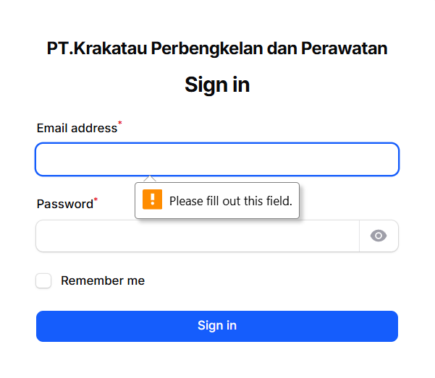 | ✅
2. | Mengisi Email salah tanpa ‘@’ | Email : ‘12345’  Password: ‘abcde’ | Validasi “sertakan’@’dalam alamat email. ‘12345’ kehilangan ‘@’.” | 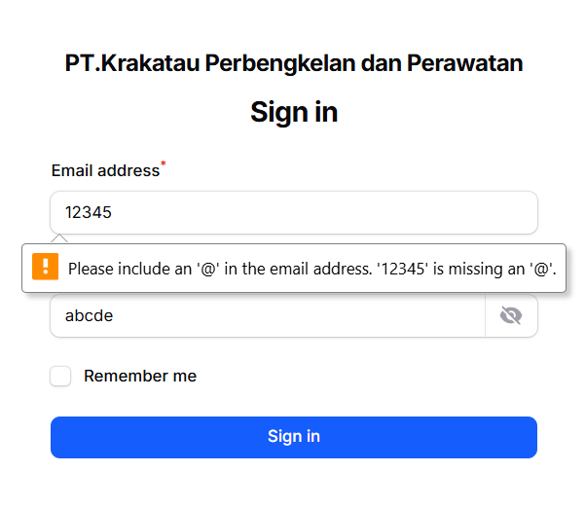 | ✅
3. | Email & Password salah | Email: nazwa@gmail.com  Password: 12345 | Validasi “These credentials do not match our records.” | 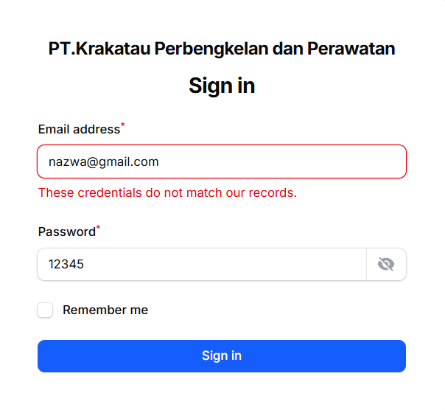 | ✅
4. | Login Valid | Email: nazwalia@gmail.com  Password: admin | Validasi “Login Berhasil memasuki Halaman Dashboard” | 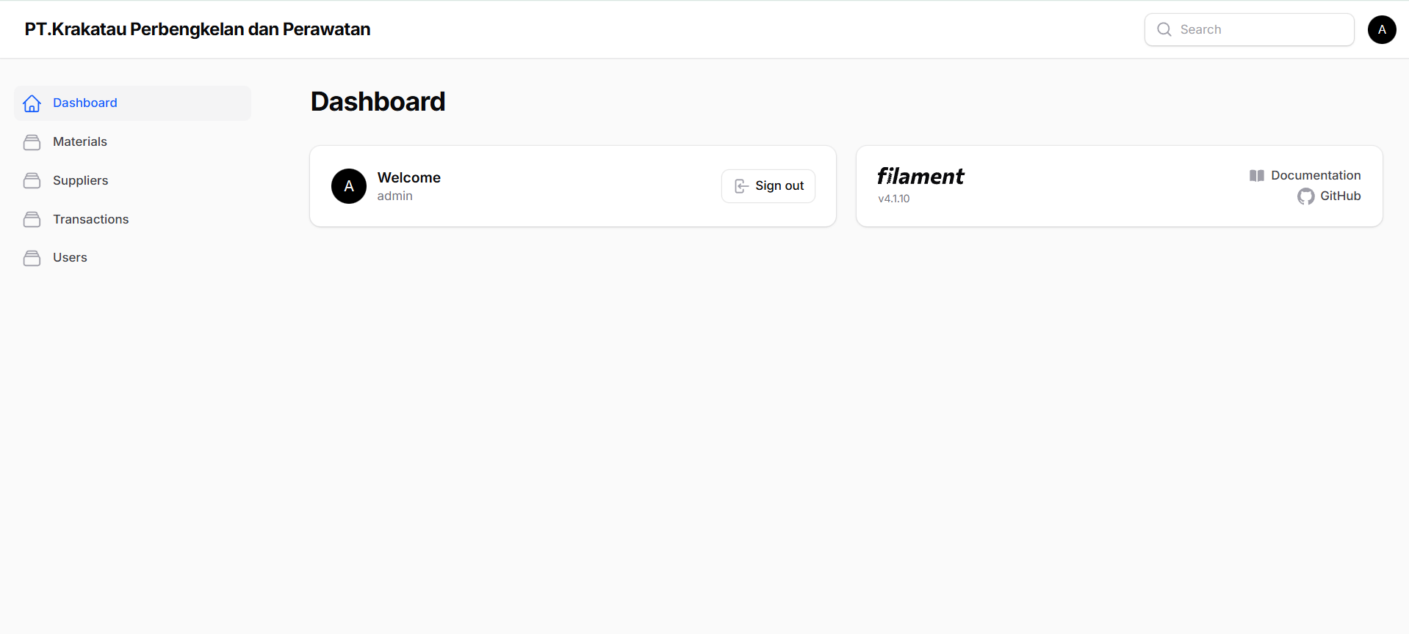 | ✅

B. Pengujian CRUD Material
No. | Skenario Uji | Input | Hasil Diharapkan | Screenshot | Hasil
1. | Create & view Material | Nama Material: Pallet  Kategori: Kayu  Satuan: pcs  Stok: 30 | Validasi “Created” dan menampilkan Halaman view material | 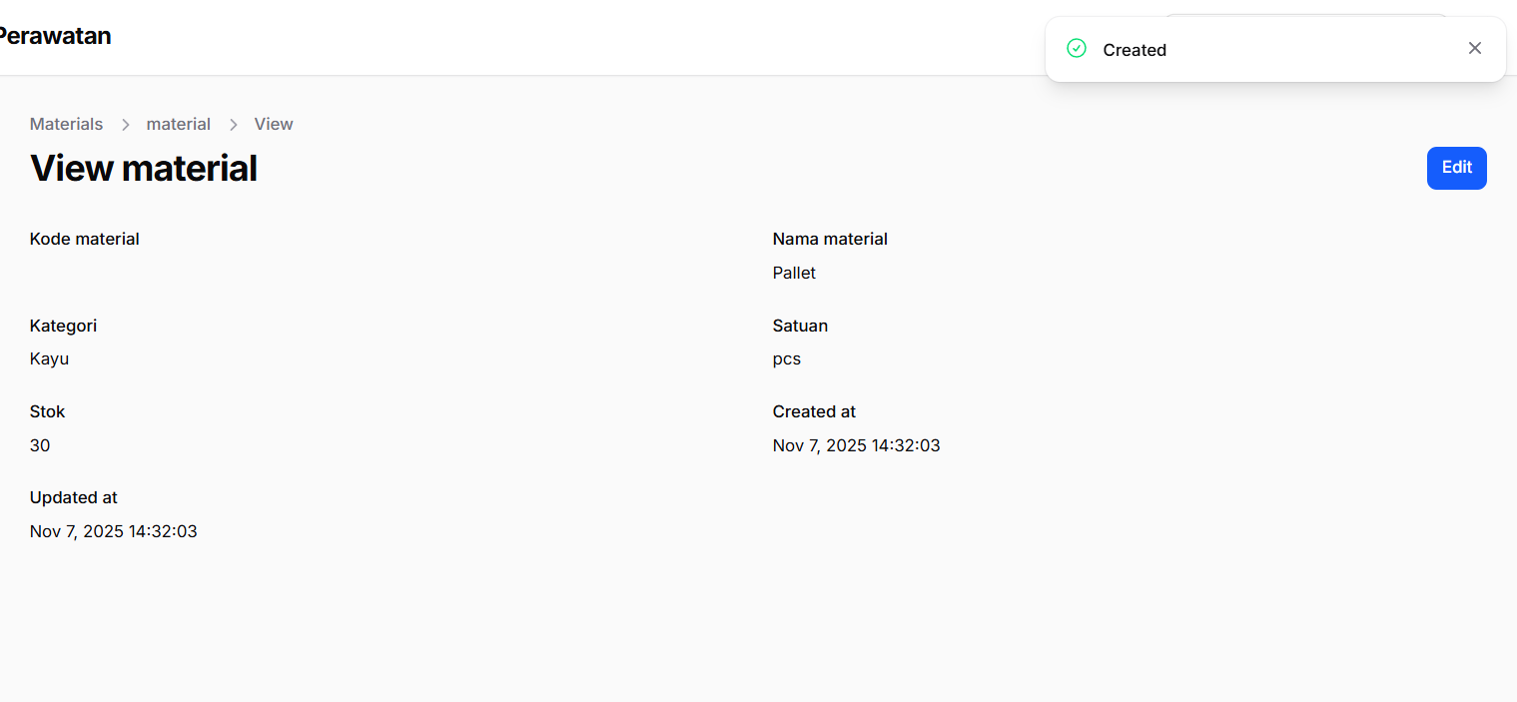 | ✅
2. | Edit Material | Nama Material: Pallet  Kategori: Kayu  Satuan: pcs  Stok: 65 | Validasi “Saved” | 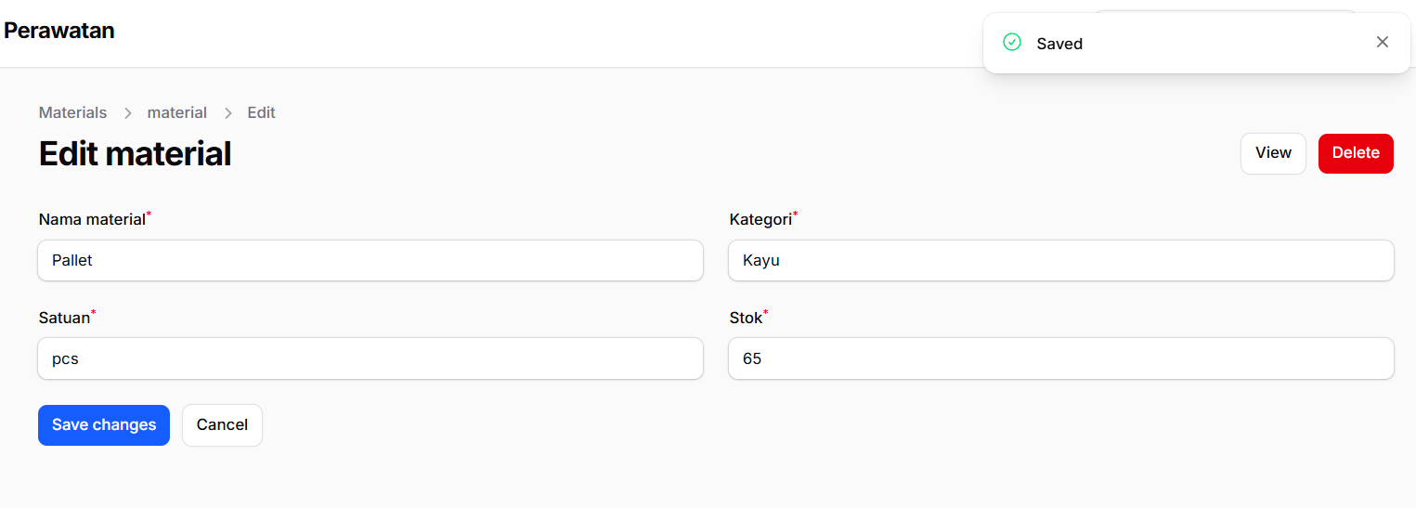 | ✅
3. | Delete Material | Click botton Delete: yes | Validasi “Delete Category are you sure you would like to do this” | 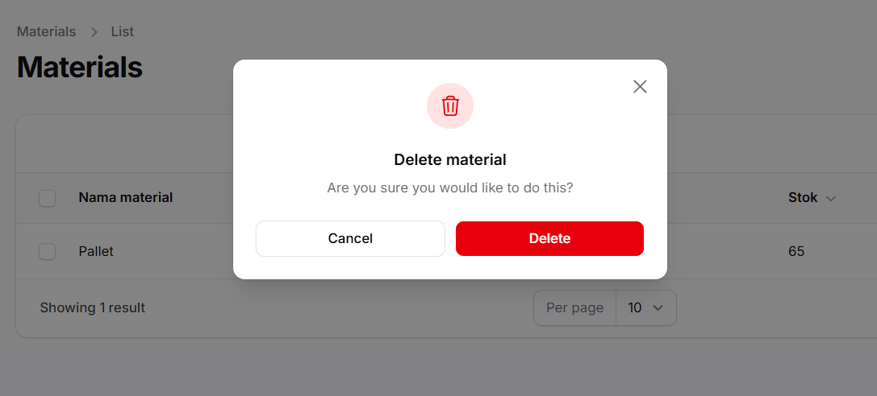 | ✅

C. Pengujian CRUD Supplier
No. | Skenario Uji | Input | Hasil Diharapkan | Screenshot | Hasil
1. | Create & view Supplier | Nama Supplier: PT. Maju Jaya  Kontak Supplier: 0854728725  Alamat Supplier: Jl. Merdeka 1 | Validasi “Created” dan menampilkan Halaman view supplier | 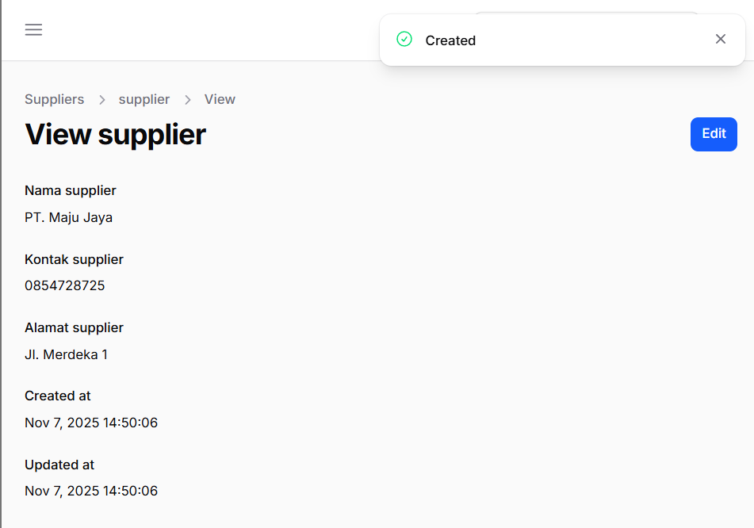 | ✅
2. | Edit Supplier | Nama Supplier: PT. Maju Jaya  Kontak Supplier: 0854728725  Alamat Supplier: Jl. Industri | Validasi “Saved” | 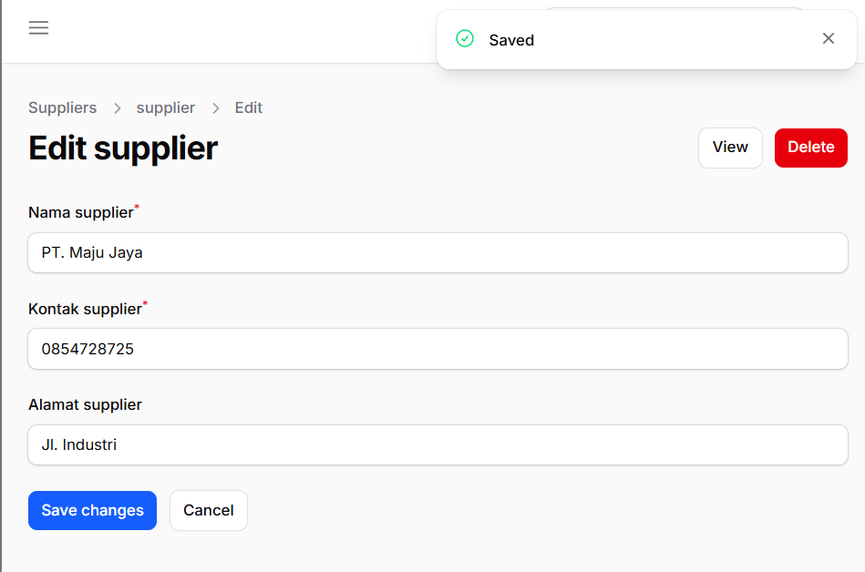 | ✅
3. | Delete Supplier | Click botton Delete: yes | Validasi “Delete Category are you sure you would like to do this” |   

